Fire Suppression Services Incorporated
3802 South 2300 East, Salt Lake City. UT 84109
Ph (801) 277-6464
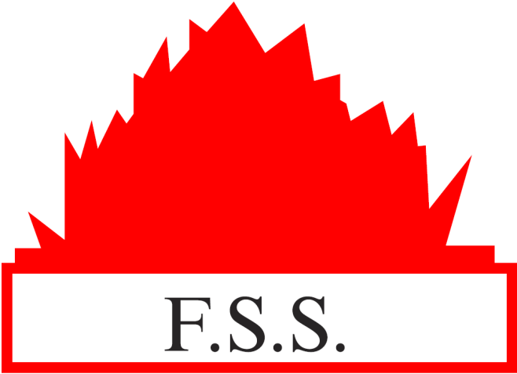
SeeJN in zzJobData-docx file
SeeSt in zzJobData-docx file
Wet Suppression INSTALL
Job# JOBNum#

PERMIT SET
Installation
Devices, Drawings etc.
DO NOT DRIVE INTO THE COMPLEX!
PARK on WASATCH
HOA WILL CHARGE FOR OIL LEAK DAMAGE ON BRICK PAVING

