Current: Real Taqueria
Address: 1869 East Murray-Holladay Rd. Holladay UT 84117

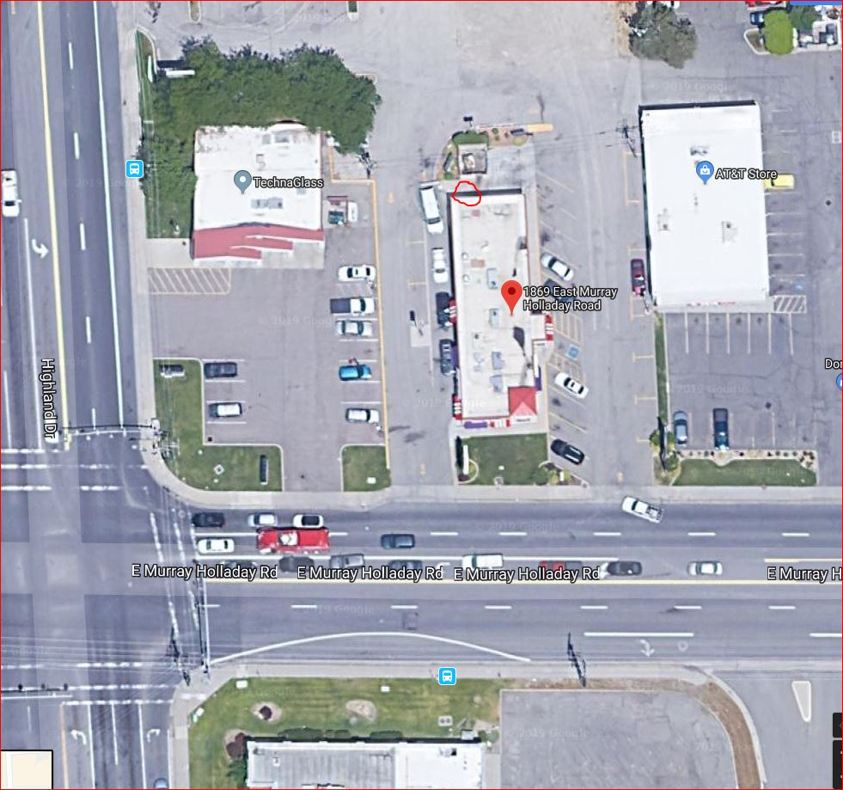 | FDC  Hydrant

