Div-31 00 00 Earthwork
32 23 00 Trench & Backfill to supply underground utility water to sprinkler riser

3.8.1.14.2 Flushing Test. A test of a piping system using high velocity flows to remove debris from the piping system prior to it being placed in service. [24, 2013]

3.8.1.15.2 Indicating Valve. A valve that has components that show whether the valve is open or closed. Examples are Outside Screw and Yoke (OS&Y) gate valves and underground gate valves with indicator posts. [24, 2013]

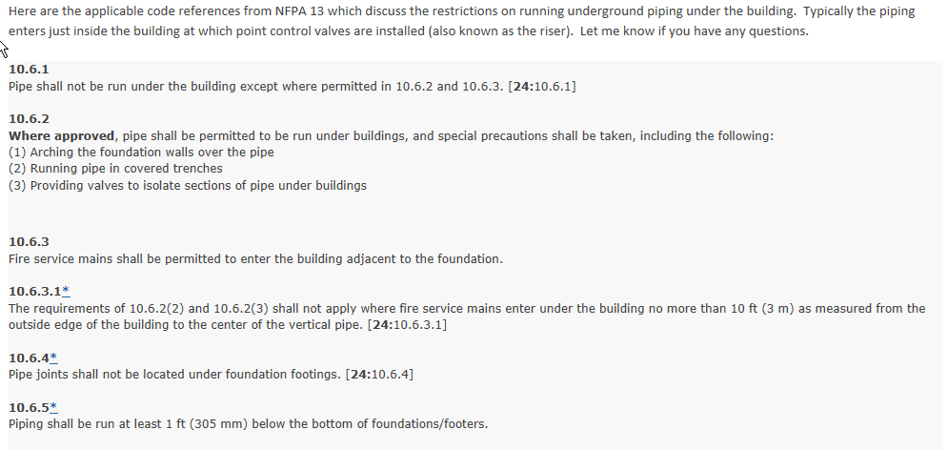

10.8.1.1* All tees, plugs, caps, bends, reducers, valves, and hydrant branches shall be restrained against movement by using thrust blocks in accordance with 10.8.2 or restrained joint systems in accordance with 10.8.3. [24:10.8.1.1]

10.10.2 Acceptance Requirements. [24:10.10.2]
10.10.2.1* Flushing of Piping. [24:10.10.2.1]
10.10.2.1.1 Underground piping, from the water supply to the system riser, and lead-in connections to the system riser shall be completely flushed before connection is made to downstream fire protection system piping. [24:10.10.2.1.1]
10.10.2.1.2 The flushing operation shall be continued for a sufficient time to ensure thorough cleaning. [24:10.10.2.1.2]
10.10.2.1.3 The minimum rate of flow shall be not less than one of the following:
(1) Hydraulically calculated water demand rate of the system, including any hose requirements
(2)*Flow in accordance with Table 10.10.2.1.3
(3) Maximum flow rate available to the system under fire conditions
[24:10.10.2.1.3]
10.10.2.1.4 Provision shall be made for the proper disposal of water used for flushing or testing. [24: Table 10.10.2.1.3]
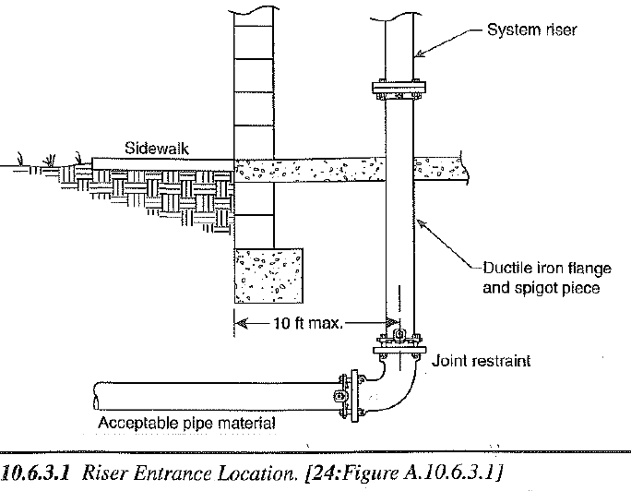 | No part of the lead-in to the flange may be covered until approved by local AHJ/Fire Marshal.  No Riser stack can be fitted until a flush test has been carried out & appropriate documentation returned to the Fire Suppression Company.
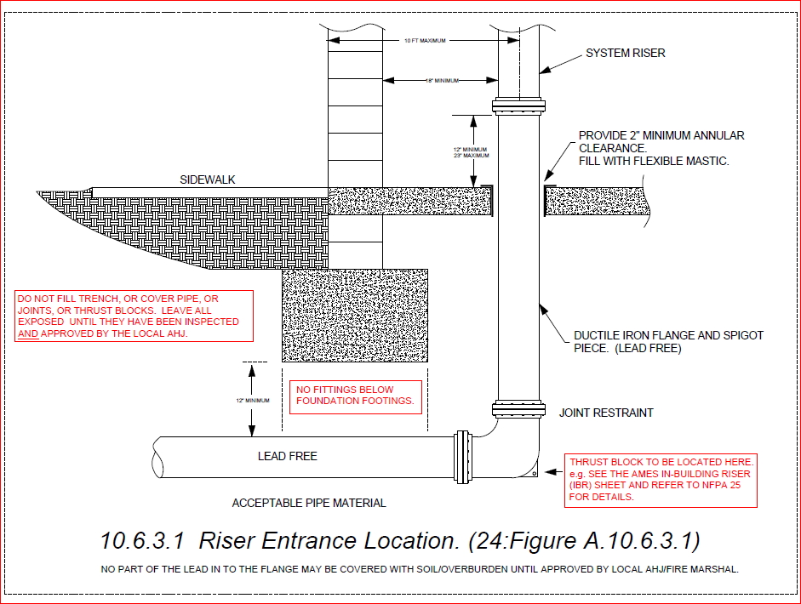 | Must be below Frostline and Lead-Free.  Joint restrains required, but not shown.

