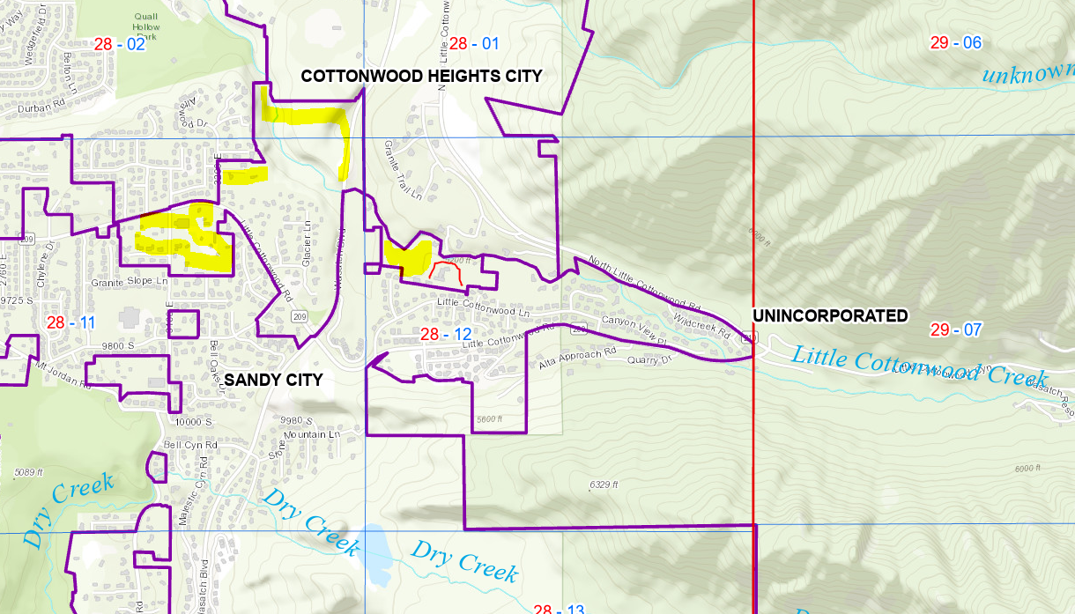 | UNINCORPORATED La Caille property, the ‘red surround I drew around the building.  Sandy Fire would ‘ATTEND’  Yellow hi-lites are unincorporated with any ‘City’, so are under the Salt Lake County.  “They are little islands, not associated with any city.”  2020-11-17 11:20. Spoke with Julie (office mgr) in Milestone; she should talk with Dave today to check where they’re permitting.  Purple lines are city boundaries.  From Sandy Water PU:  When a 10 inch water line is looped,  then we could get:  - 3200 psi with 40 psi remaining.  - Static pressure is 130 psi.  When there’s no looped line,  you could only get  - 2400 gpm at 30 psi.  - static pressure is 110 psi.

HYDRANTS
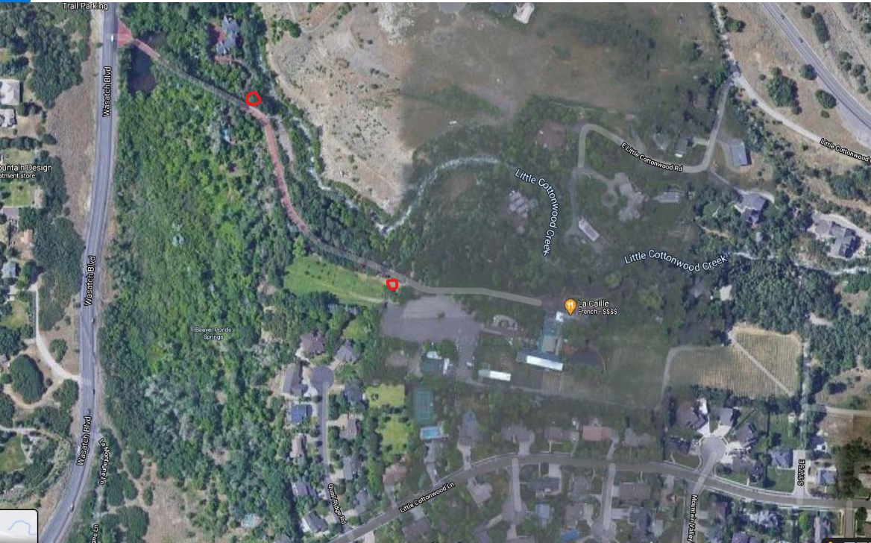  Hydrant 3  Hydrant 1  Hydrant 2  Deer Park  The Cottage | Vault (Orange Cover)  Proposed 10” Line
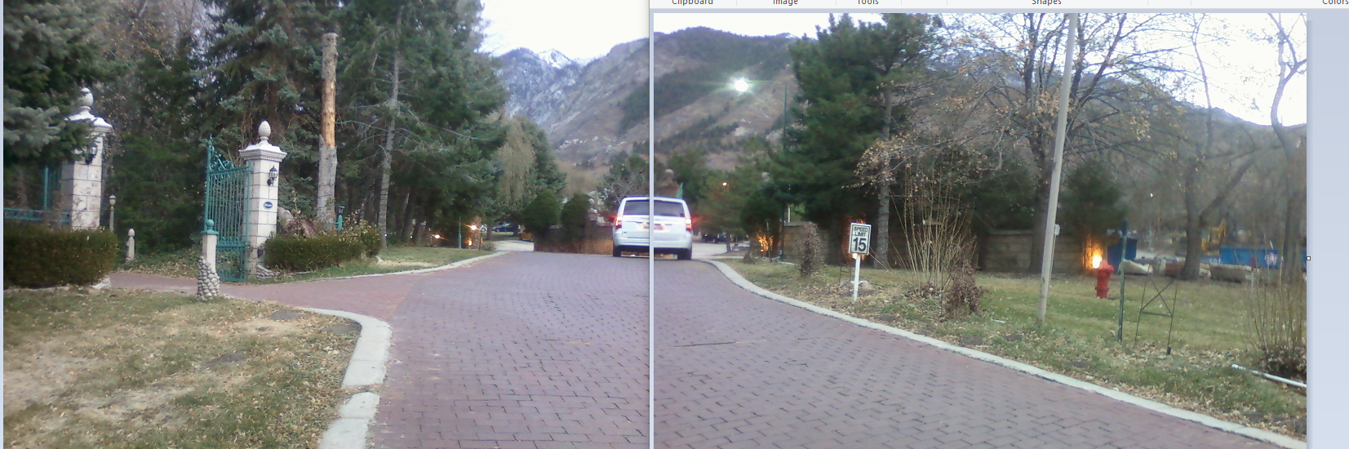

Hydrant 2. On the right, by the flame, in the ‘Deer Park’
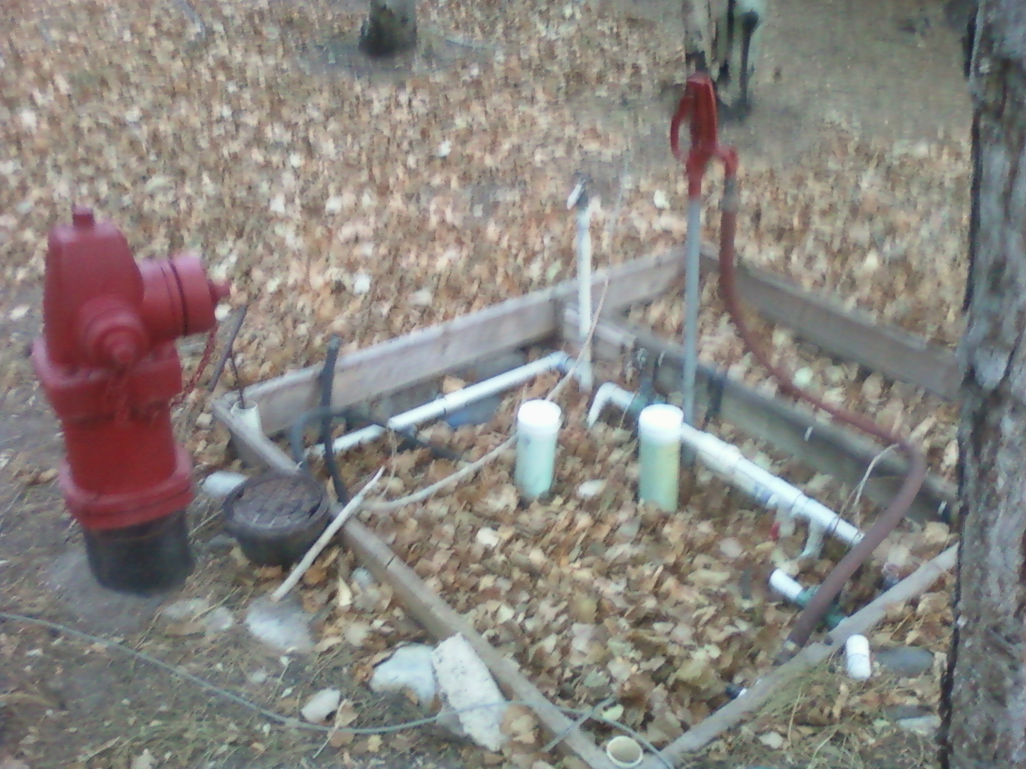

Hydrant 1. Opposite ‘The Cottage’
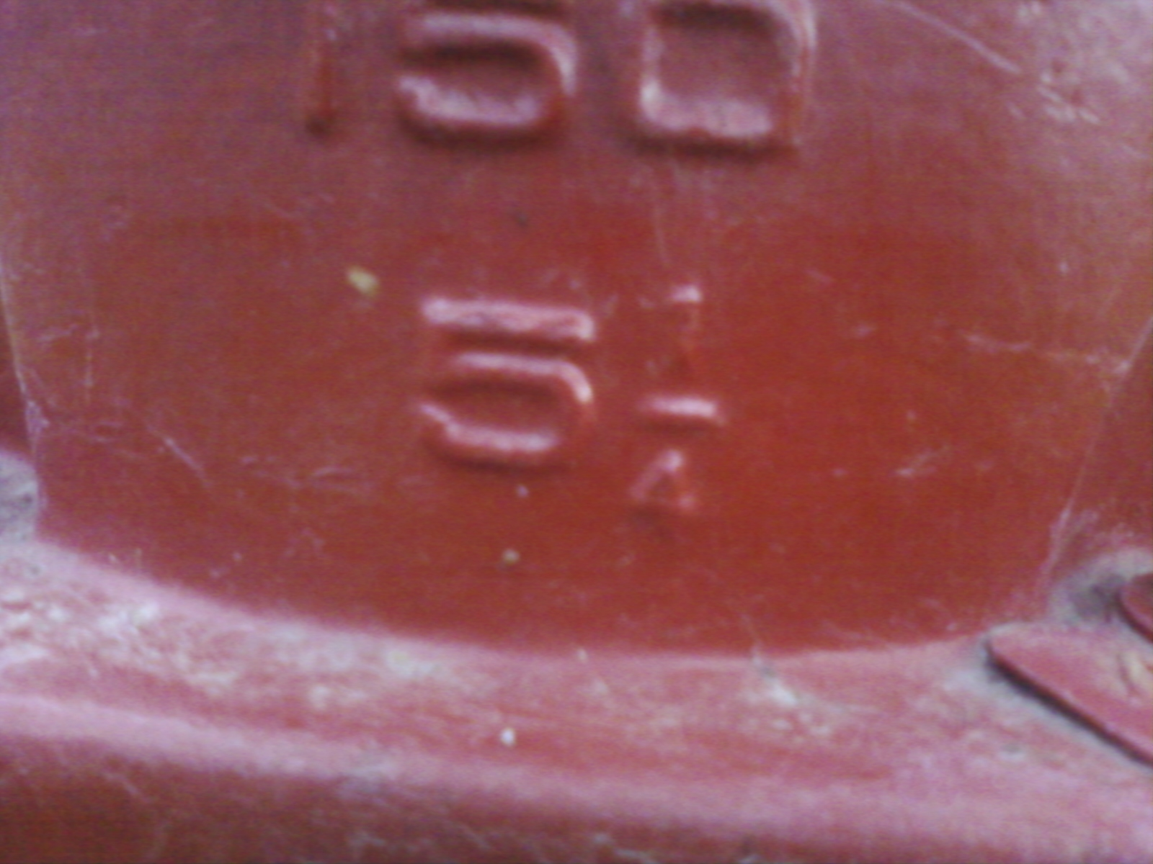
The cottage hydrant 1
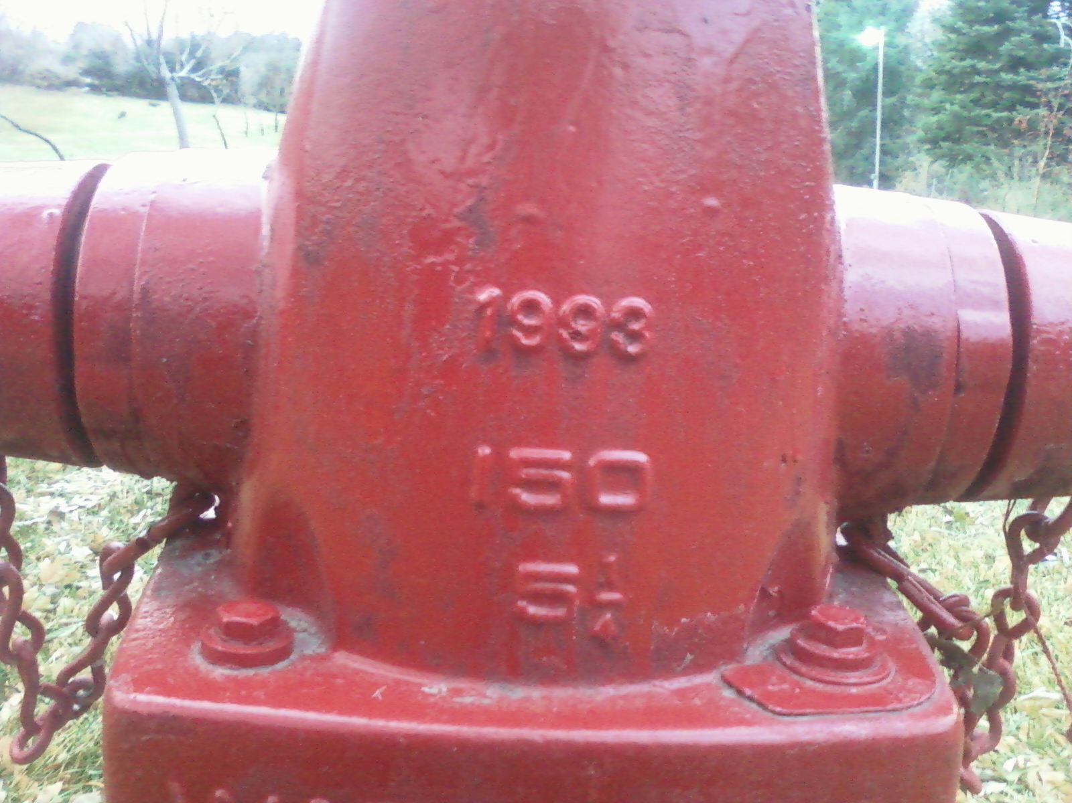
The Deer Park Hydrant 2

