**December 14, 2020**

**Arun Fire Suppression Service – FINAL FIRE REVIEW**

Fire Suppression Service, Inc. Client Permit No.: N/A

3802 South 2300 East WC**3** Job No.: 220-715-002

Salt Lake City, UT 84109

Phone: 801-277-6464

**arunFSS@live.com**

**Re: Plan Review: La Caille - FSS**

**Address:** **9565 South Wasatch Boulevard, Sandy, UT**

West Coast Code Consultants, Inc. (WC3) has completed the final review of the following documents for the project referenced above on behalf of Fire Suppression Service, Inc.:

1. Fire suppression plans: dated 11/15/2020, by Fire Suppression Services.
2. Specifications: .

The 2018 IBC, IFC, IMC, 2017 NEC, and applicable NFPA standards, were used as the basis of our review. **Please note that our review has been completed and we have no further comments, and no further submittals are required.**

Please note that West Coast Code Consultants’, Inc. (WC3) plan review is limited only to the provisions regulated and enforced by the State of Utah. Please be aware that additional comments in relation to this application may be generated by other divisions/departments within the jurisdiction. Please do not return plans until all comments from all applicable divisions/departments have been addressed.

Please call if you have any questions or if we can be of further assistance.

Sincerely,

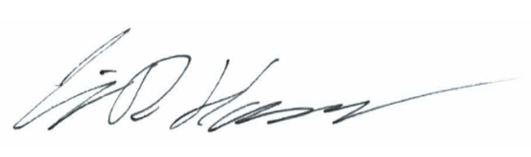

**West Coast Code Consultants, Inc. (WC3)**

Fire Plan Review By:

Craig Hanson, Fire & Life Safety Plans Examiner

cc: Fire Suppression Service, Inc. Staff